Power BI Assignment 1
Data transformation and data modelling
- Added Location Column
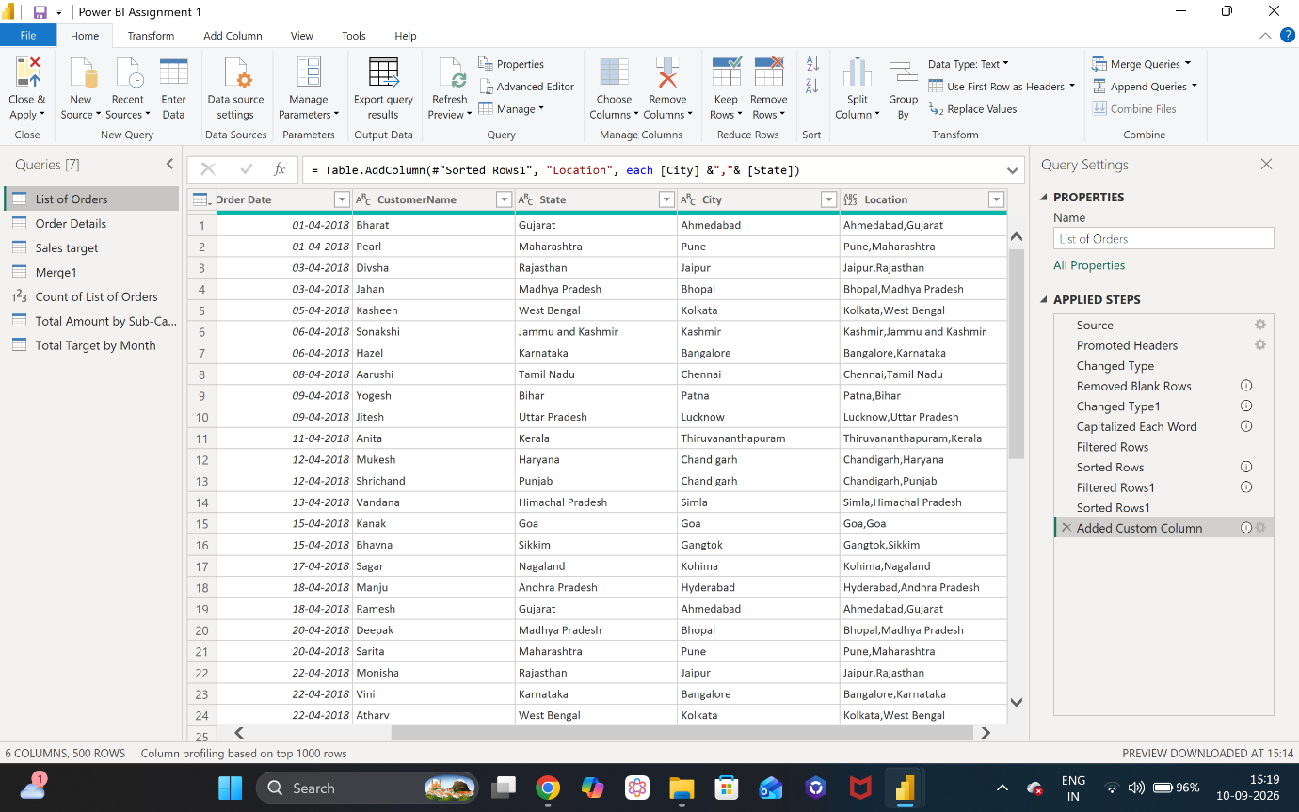
- Added Conditional Column
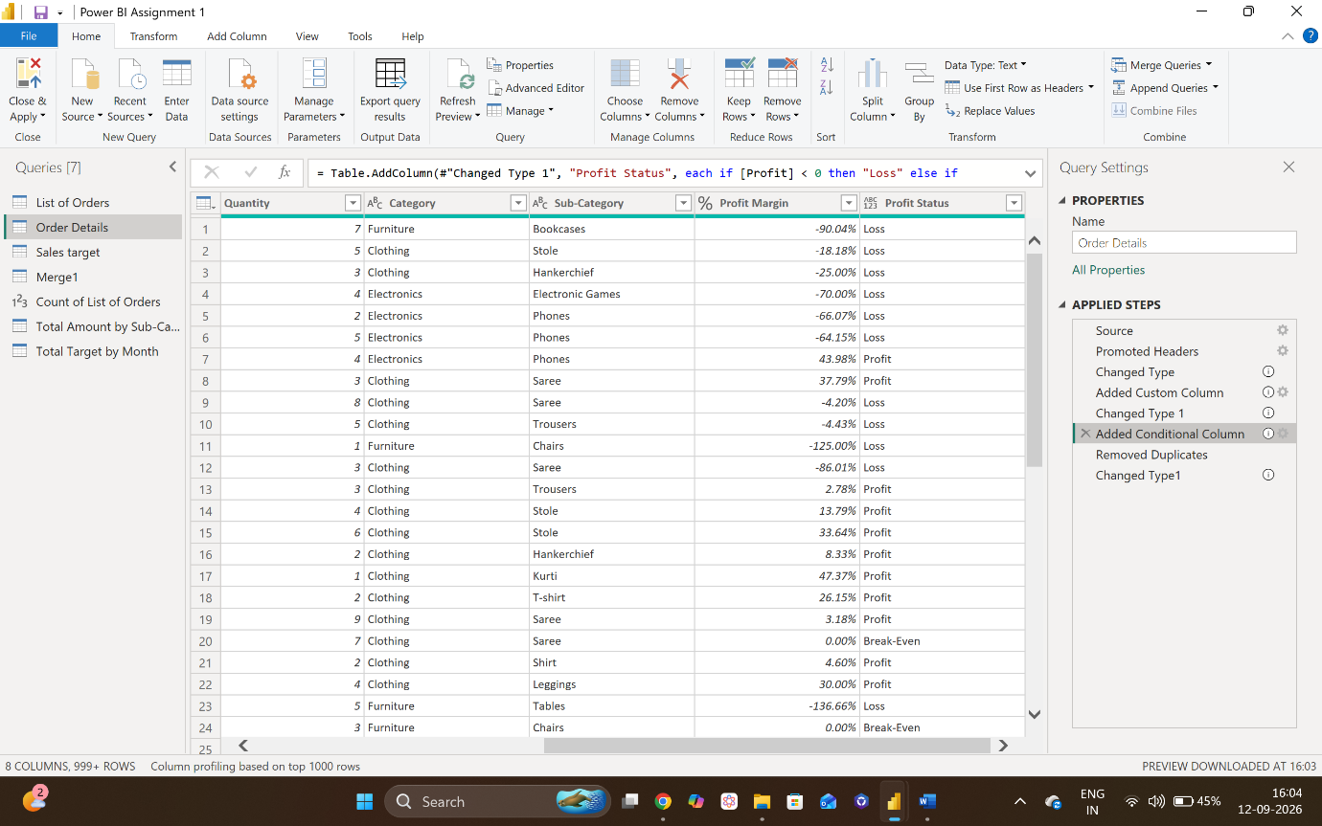
- Merge (Joins)
Merged List of Orders and Order Details tables and expanded.
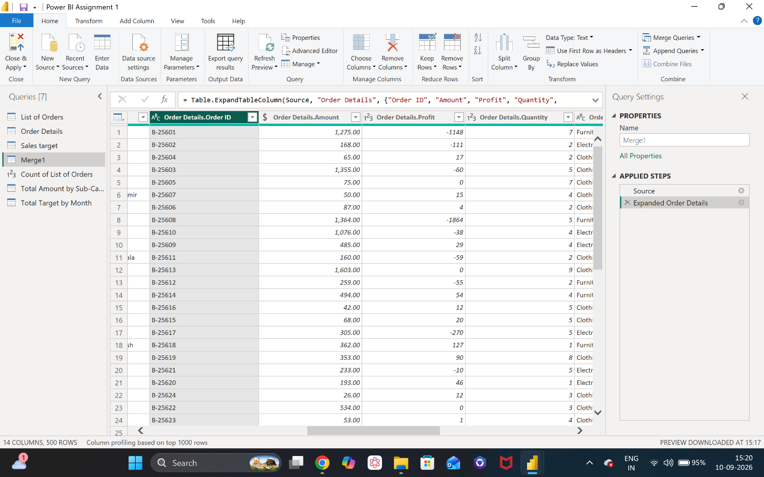
- Count
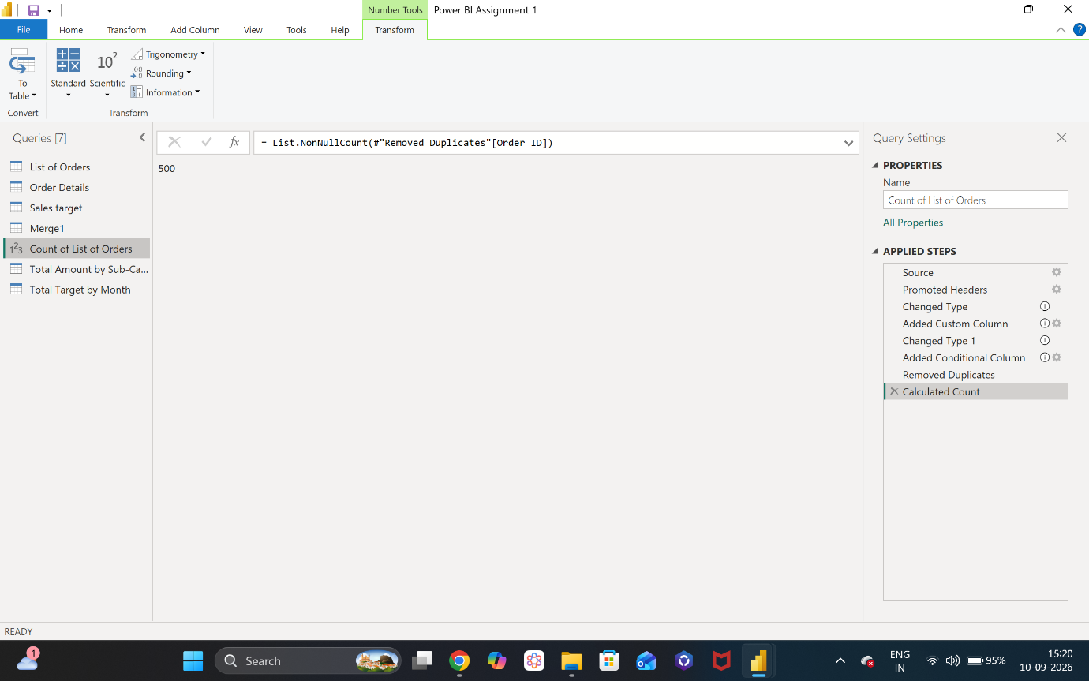

- Filtered only TAMILNADU
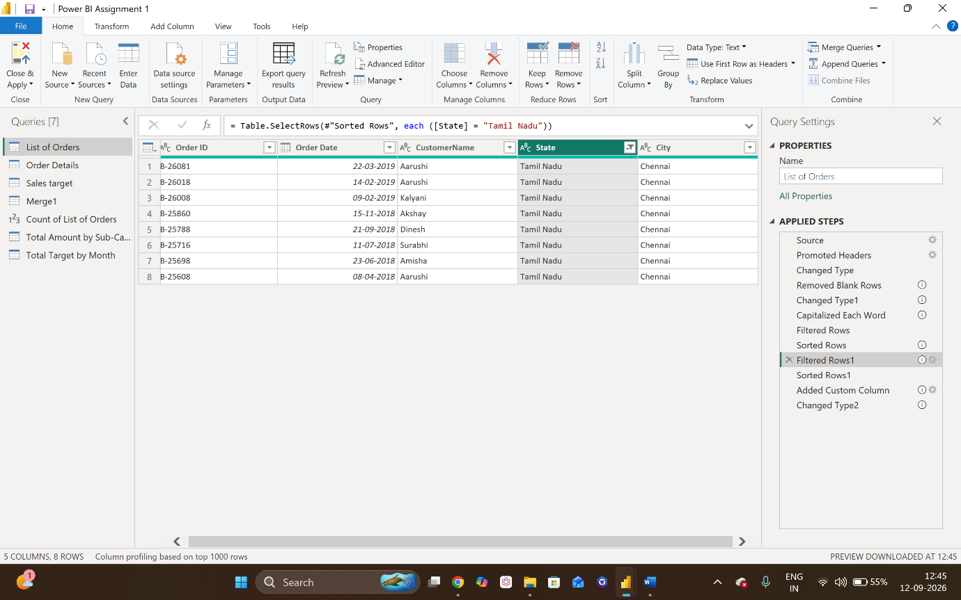
- Total Amount by Sub-Category
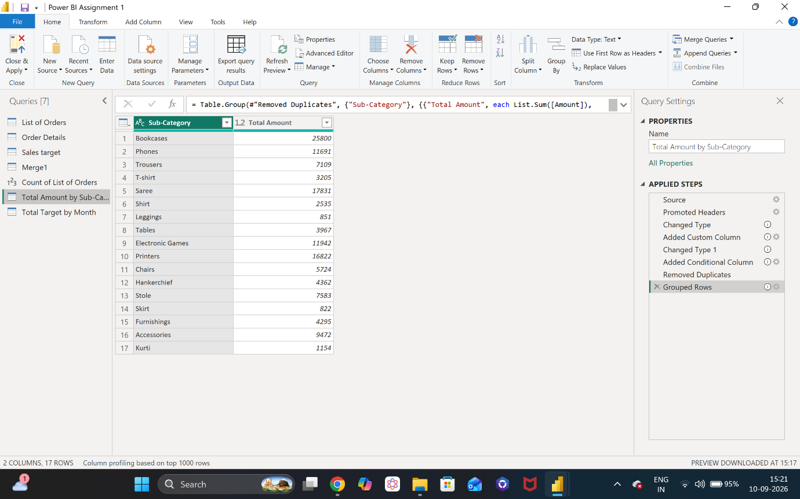

- Total Target by Month of Order Date
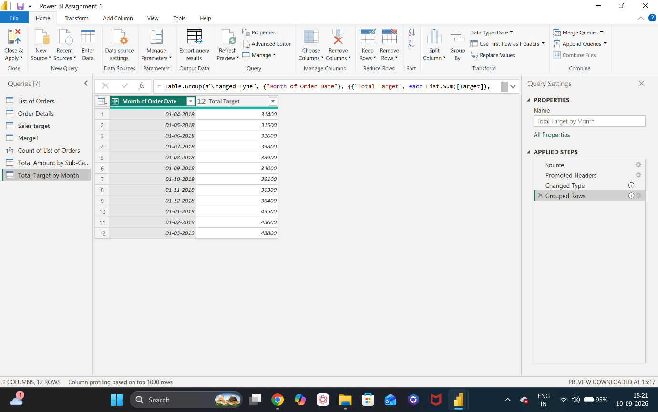
- Group By
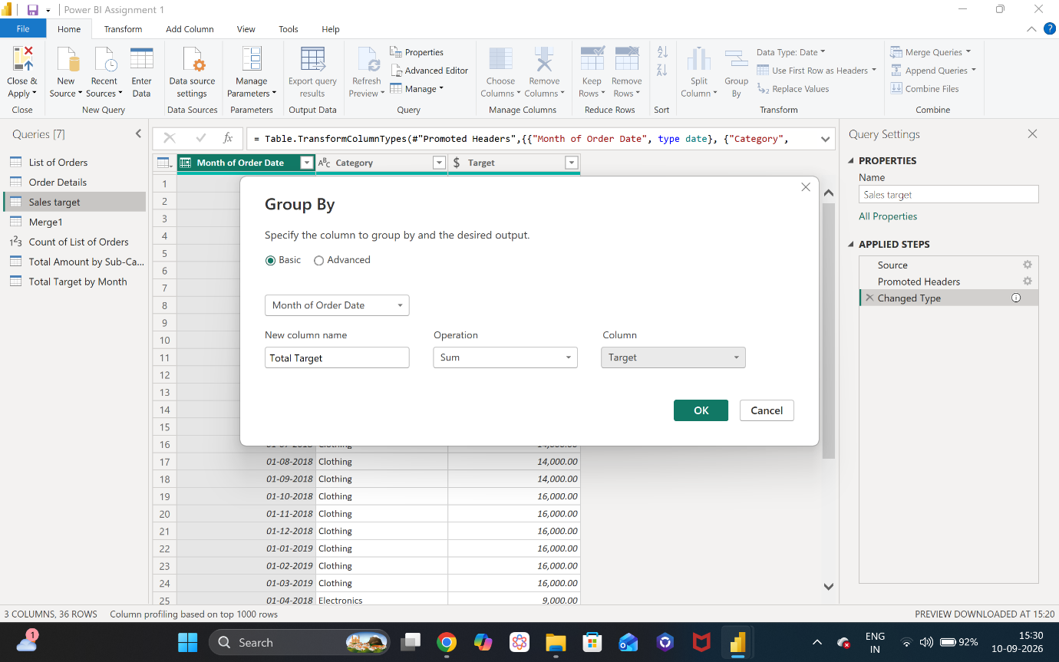

- Data modelling
    - Model view ( 1-1 Relationship for List of Orders and Order Details,
*-* for Order Details and Sales Target)
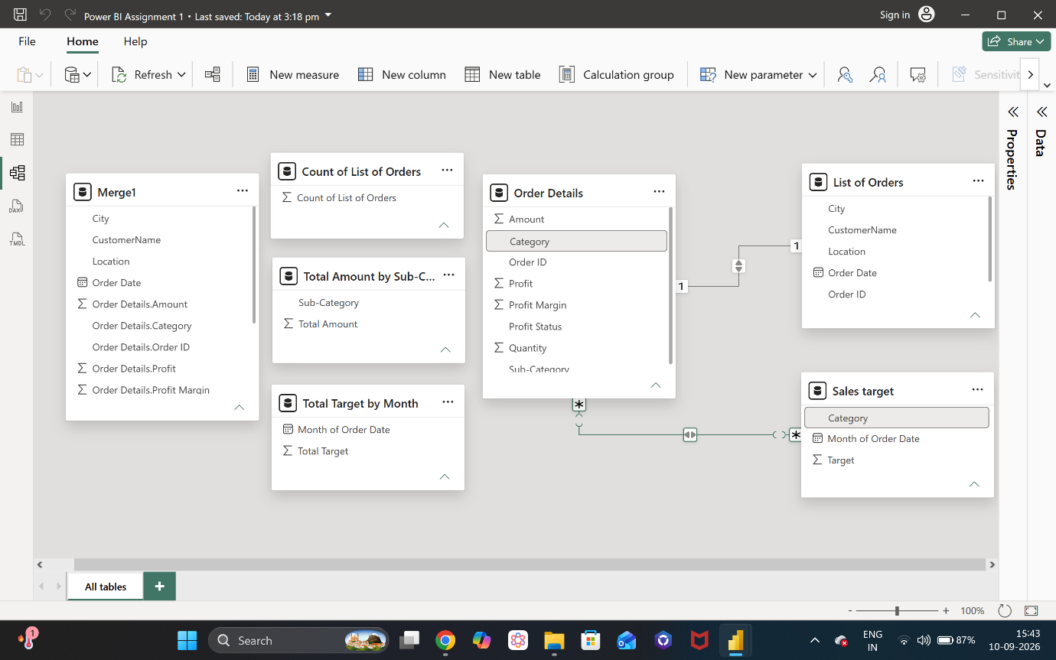
    - Manage Relationships
